**Problem Statement:**

You are an IT Support Administrator and are charged with the task of creating credentials for new hires

Your application should do the following:

1. Generate an email with the following syntax

firstNamelastName@department.company.com

1. Determine the department (Technical, Admin, Human Resource, Legal)
2. Generate a random password which will contain (number, capital letter, small letter & special character)
3. Display the generated credentials
4. Use parameterized constructor of class Employee, to pass firstName, lastName.
5. Create a separate CredentialService which will have generatePassword, generateEmailAddress, & showCredentials method.

Sample output

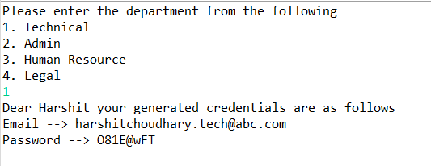

Dear Harshit your generated credentials are as follows

Email ---> harshitchoudary@tech.abc.com

Password ---> 181E@wFT